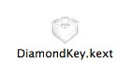

1. What Is DiamondKey?
Control + E: | ↑
Control + X: | ↓
Control + S: | ←
Control + D: | →
Control + R: | Page-up
Control + C: | Page-down
Control + H: | Delete
DiamondKey is a software utility for adding a Diamond Cursor function to Mac OS X. The Diamond Cursor function assigns the functions of horizontal and vertical cursor keys (arrow keys) of the keyboard to combinations of the Control key and the E, X, S, D, R, C, and H keys. It therefore enables you to move the cursor on the screen with just your left fingers. Although probably unfamiliar to Macintosh users, the Diamond Cursor function is often incorporated in command-oriented systems and text editors. DiamondKey is a very convenient function and can be used for all Mac OS X operations.
DiamondKey assigns the arrow, page-up, and page-down functions to the following key combinations:

2. DiamondKey Functions
DiamondKey has the following functions:
Adding the Diamond Cursor function to Mac OS X

Assigning the Command key function to the Katakana/Hiragana key
On the Japanese JIS keyboard, you can use the Katakana/Hiragana key on the right of the Space bar as the Command key. This function is useful for users of the iBOOK and PowerBook, which do not have a Command key.
Assigning the `/~ key function to the Alphanumeric Input key
On the Japanese JIS keyboard, you can use the Alphanumeric Input key on the left of the Space bar as the `/~ key. This key position is familiar to users of the Apple standard keyboard.

3. How To Install DiamondKey

Follow the procedure below to install DiamondKey on your Macintosh.

(1) Removing conflicting files
Remove the files that have an equivalent function to DiamondKey from your Macintosh (e.g., the kext files that replace key functions). Utilities such as DoubleCommand, SwapCommandOption, Kappa, and Telsa cannot be used together with DiamondKey because these programs are similarly based on iJect. If you find any of these utilities installed on your Macintosh, uninstall them as instructed in the user's guide.

(2) Expanding the compressed DiamondKey file
Expand the downloaded compressed DiamondKey file. The file is compressed using the StuffIt format (.sit) and can be expanded by the StuffIt Expander located in the Utilities folder of Mac OS X.

(3) Copying the DiamondKey folder into the system
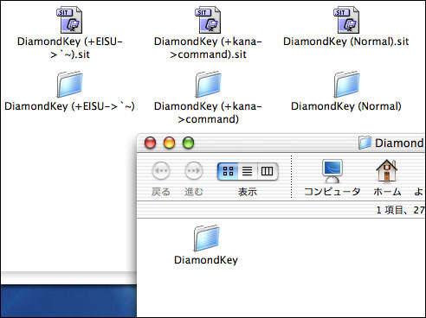
When the compressed file is expanded, folders named DiamondKey (Normal), DiamondKey (+kana->command), and Diamond (+EISU->`~) appear. Each of these folders includes a DiamondKey folder. Copy the necessary DiamondKey folder into the system as follows.

Expand the compressed file, and copy the DiamondKey folder into the system.

The copy destination is "/Library/StartupItems". Open the Startup disk, open the Library folder, and drag the DiamondKey folder into the StartupItems folder in the Library folder. If the StartupItems folder is not found, create it with the correct name (StartupItems). Only users
with Administrator authority
are allowed to perform the
above operation.

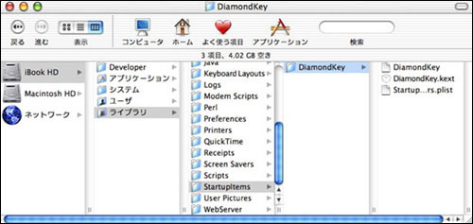

Copy the DiamondKey folder into the system so that it is finally installed in the status as shown in the figure.

(4) Restarting the system
Lastly, restart your Macintosh. Do not simply log off the system, but restart it. DiamondKey will start operating after the system is restarted. If your system is Mac OS X 10.2, a warning message is displayed immediately after DiamondKey is installed. In this case, select "Continue to use after recovery" in the message box.

